Workshop on Cross-Linguistic Semantics of Reciprocals
Utrecht University | 7 October 2019

Encoding interpretive dependencies
A comment on Scattered Reciprocals by Filipe Kobayashi
Eric Reuland, UiL OTS
1. Introduction
Kobayashi's paper addresses a very interesting issue: The interpretation of scattered reciprocals, as in (1):
(1) Os alunos falaram um com a orientadora d-o outro.
the students spoke one with the supervisor of-the other
‘The students spoke with each other’s supervisor.’

The question is:
- How to represent the dependency between the elements um and o outro in Brazilian Portuguese, which together give rise to a reciprocal interpretation.

Kobayashi's answer is given in the form of a very precise and explicit analysis.
- My focus: the relation between the morphosyntactic realization of reciprocals and their semantics.
- My suggestion: It is worthwhile to explore a more transparent relation.

The general schema Koboyashi presents is given in (2):
(2) Schema for Scattered Reciprocals
[ Antecedent ...[ one/um ...[ ...other/o outro ...] ] ]

He convincingly shows that i) the dependency between the antecedent and um is subject to standard locality conditions, whereas ii) the dependency between um and o outro may cross syntactic islands.

Moreover SRs differs from English each . . . the other(s) sentences such as (3=7), which have a more restricted range of readings:

(3=7) The students each talked with the supervisor of the other(s).

Since syntactic movement is constrained by locality Kobayashi concludes that
i) follows from the analysis of um as a floating quantifier (the antecedent originally forms a constituent with um stranding the latter by moving out);
ii) indicates that one/um and other/o outro do not form a syntactic constituent at any point in the derivation of SRs; these two phrases are syntactically autonomous.

Kobayashi considers two approaches concerning the mapping between syntactic structures and reciprocal meanings.

- Heim et al. (1991) on each other: morphological complexity reflects semantic complexity: two semantic operations: distributivity and differentiation, each corresponding to one of the pieces of each other
Recip = Dist + Diff
- Dalrymple et al. (1994) and Dalrymple et al. (1998): reciprocal constructions, regardless of their morphosyntax, are universally mapped to Recip, a multiply ambiguous quantifier over pairs of type (et)(eet)t.
a single quantifier is responsible for Heim et al.’s distributivity and differentiation.

Summary:

Application to SRs in BP
um denotes Recip, while o outro is just interpreted as a variable marking the second argument of the reciprocated relation.

Kobayashi shows that in this form these approaches yield different predictions, illustrated on the basis of the sentence in (4)=(30):
(4)

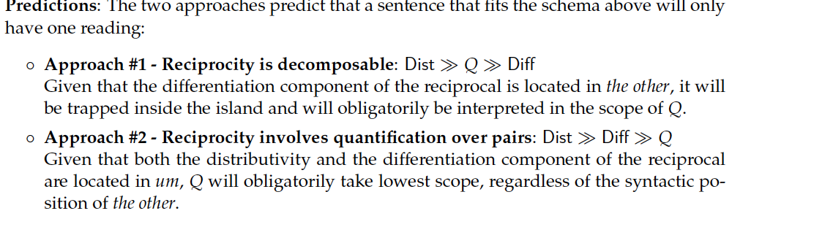
These predictions are tested in (5=32/33):
(5)
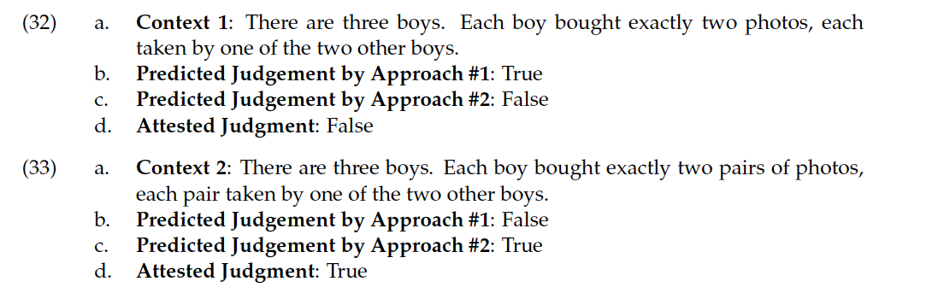
It is concluded that the polyadic quantifier approach makes the correct predictions.

2. Comments and questions
Consider the relation between um and o outro in the approach presented. See (6=46-49)

In the initial informal sketch the distributivity and differentiation components were taken to be both located in the position um. However in order to derive the ill-formedness of (46) with a pronoun ele, the semantics of o outro is enriched as in (47).

(6)
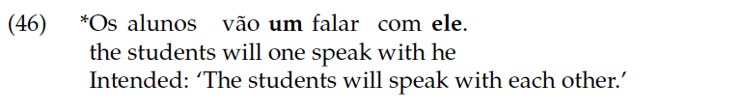

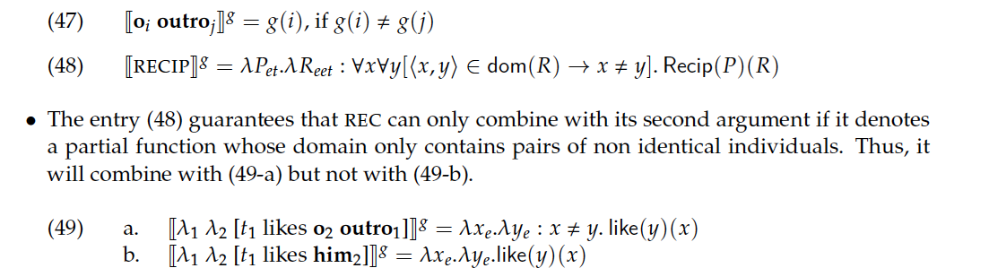

Specific Comments and Questions
i) This account in fact reintroduces a separate differentiation component in the position of o outro, making the two approaches compared in fact more similar than it might initially seem.
ii) In the final version the Recip operator does not coincide with um, but is introduced as a separate null element REC.
- This may be descriptively needed, but it is unclear where it comes from.
iii) This raises the question at which point in the derivation REC is inserted, and how precisely is the insertion of REC conditioned by um and o outro? As a Determiner, why doesn't it affect stranding of um?
iv) The requirement that REC puts on its second argument requiring it to have the type of o outro looks quite similar to a selection requirement. Selection requirements are generally taken to be local. In (46) it is, but not in (4=30). How can such a requirement across a syntactic island be motivated?

- In fact, one would expect that the presence of um and the presence of o outro together would present sufficient information for the computational system to arrive at a reciprocal interpretation.

v) As Kobayashi notes at another occasion Brazilian Portuguese has a different reciprocal construction, where um is in an argument position, but need not command o outro.

(7)

It would be interesting to flesh out in detail the differences in the status of um and o outro in (7) as compared to (4). Does it involve ambiguities? If so, which?

3. A very tentative follow-up
It seems that the main question concerning (4) can be formulated as in (8):
(8) How do we reconcile the fact that in (4=30) um …. o outro behaves as a complex polyadic quantifier with the fact that the relation between these elements is not sensitive to syntactic island conditions?

Do we have operations that may combine two different syntactic objects into one semantic object, and/or induce the scopal effect Dist >> Diff>> Q observed?

(9=43/44) do involve variable binding as a dependency. It is part of the grammar, but insensitive to islands
(9)

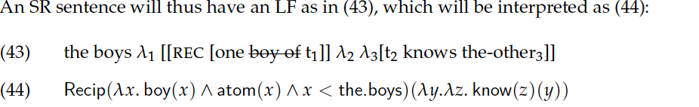

Can we avoid stipulating an underived null polyadic quantifier Recip, but rather derive the interpretation obtained from independent components of the structure?

Tentative suggestion 1: Assume that in the schema of (2), um [or rather [Ø_{NP} um]] A-binds o in o outro, and that the Differentiation function is situated in o outro. Could binding allow Diff to combine with the Distributivity function in um, and scope over Q, without the insertion of an independent operator REC?

To put it differently, can a variable binding dependency contribute to emulating the effect of a polyadic quantifier shown in (4=30) by other means?

A suggestive pattern in Dutch.
Staying close to Kobayashi's example, in Dutch its direct counterpart with de anderen ' the others' behaves scopally as expected. The judgment is quite clear: (10) only has the interpretation of 2 photo's per boy.
(10) De jongens kochten elk 2 foto's die de anderen genomen hadden.
The boys bought each 2 photo's that the others took.

But: What happens if we build in some further explicit dependencies, combining distribution, and differentiation with a binding dependency?

Consider (11):
(11) a. De tennissers kochten elk 2 foto's die hun tegenstanders genomen hadden.
The tennis players each bought 2 photo's that their opponents took.
b. De tennissers kochten elk 2 foto's die ieder van hun tegenstanders genomen had.
The tennis players each bought 2 photo's that each of their opponents took.
c. De tennissers kochten elk 2 foto's die hun tegenstanders ieder genomen hadden
The tennis players each bought 2 photo's that their opponents each took

Relevant properties:
- High distributivity: elk
- Binding dependency: tennissers-hun
- Lexically represented differentiation: tegenstanders 'opponents' within the set of tennis players
- Low distributivity: ieder

Result: In (11b,c) what is bought by the tennis players are pairs of two photo's.
- This appears to emulate the polyadic quantifier interpretation just as in the case of um – o outro.

Suggestion: o outro is neither just a variable, nor a variable over pairs of non-identical individuals, but it combines both a component expressing differentiation and a component expressing distribution.

Summarizing: um binding o and a richer semantics of o outro may emulate the polyadic quantifier interpretation, capturing the results presented but simplifying the analysis and retaining a more transparent relation between morpho-syntax and semantic interpretation.

Suggestion for testing the relevance of a variable binding based dependency:
- When um does not c-command o outro, as in (7) one would expect the polyadic quantifier reading to be absent. Is this correct?

